**INTI International College Penang School of Engineering and Technology**

**3+0 Bachelor of Science (Hons) in Computing,**

**in collaboration with Coventry University, UK**

Coursework cover sheet - Section A

|  |  |
| --- | --- |
| Full Name: Ong Zheng Yang | |
| CU Student ID Number: P21013454 | |
| Semester: 1 | |
| Session:  **August 2022** | |
| Lecturer:  **Nadhrah Abdul Hadi (nadhrah.abdulhadi@newinti.edu.my)** | |
| Module Code and Title:  **4067CEM Software Design** | |
| Assignment No. / Title:  **Continuous Assessment** | % of Module Mark:  **50** |
| Hand out Date:  **6th September 2022** | Due Date:  **Task 1: 30 September 2022, by 11.59pm.**  **Task 2: 18 November 2022, by 11.59pm**  **Task 3: 4 November 2022, by 11.59pm.**  **Task 4: 4 November 2022, by 11.59pm.**  **Task 5: 4 November 2022, by 11.59pm.** |
| Penalties: No late work will be accepted. If you are unable to submit coursework on time due to extenuating circumstances, you may be eligible for an extension. Please consult the lecturer. | |
| Declaration: I/we the undersigned confirm that I/we have read and agree to abide by the University regulations on plagiarism and cheating and Faculty coursework policies and procedures. I/we confirm that this piece of work is my/our own. I/we consent to appropriate storage of our work for plagiarism checking.  Signature(s): ________________________ | |

**Software Design User Story Mapping Assignment 1**

* 1. **Goal**

The Friendly Buddy app was created to help students at INTI Penang meet more people on campus. Today's students have relatively small social circles and only know their classmates. Encourage college students to make more friends, particularly individuals who have various hobbies and personalities. The friendly buddy app can help students locate friends who share their interests and can help timid and introverted students connect with others online. Students at INTI Penang can get to know one another better thanks to this app.

* 1. **User**

Users of the Friendly Buddy App concentrate on INTI students in order to reduce the gap between them and introduce them to more individuals in various professions. By using this app, students can get to know one another better and discover their common interests and classes. Additionally, you might learn from it and their your career.

* 1. **Values and Benefits**

The primary benefit of utilising the Friendly Buddy App is that students at Inti Penang can make more new acquaintances and expand their social networks.

To extend their horizons is the second. Students from other areas can interact with one another to pique their curiosity and inspire a desire to learn more about subjects that are typically unattainable.

The Friendly Buddy App's third and final advantage is that it fosters social skills. Due to the outbreak, students have been staying at home for far too long and haven't socialised, making them feel very uncomfortable and frightened. If INTI Penang students are permitted to use this app to connect with others and make friends, it must enhance their social skills.

* 1. **Google Form Survey Question**

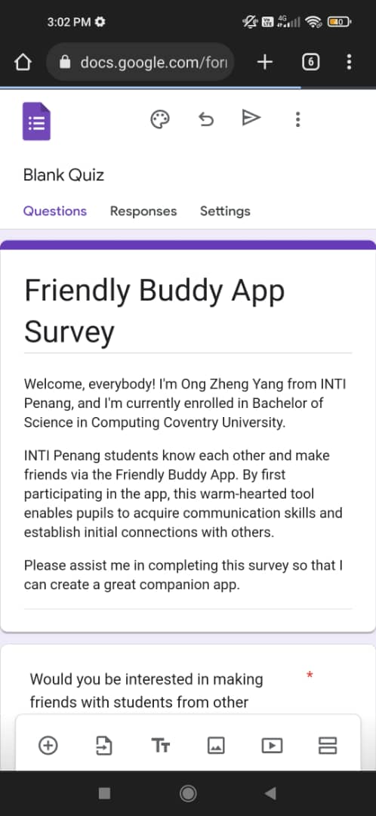

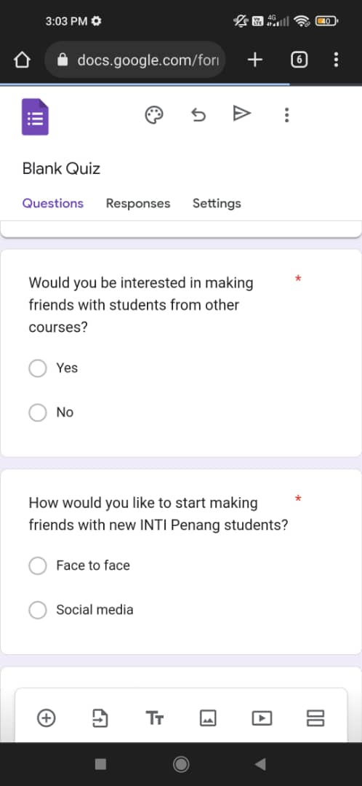

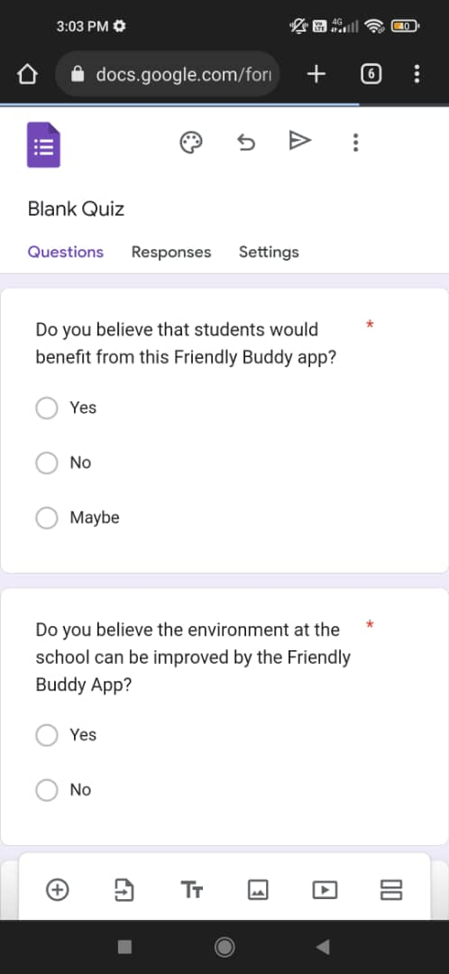

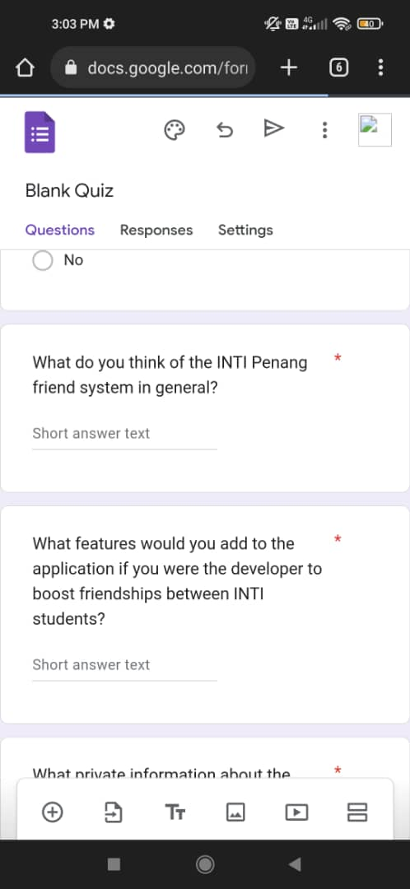

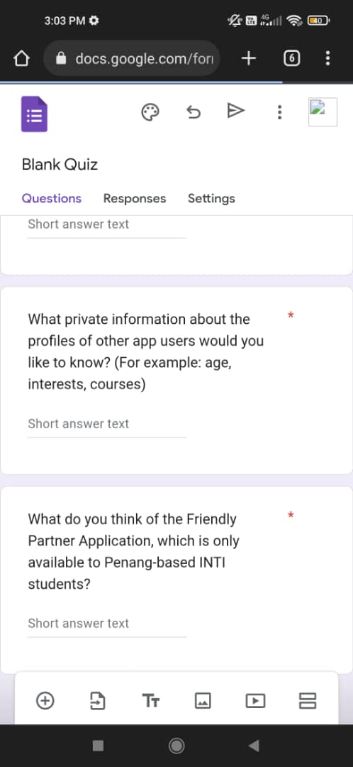

* 1. **Google Form Survey Responses**

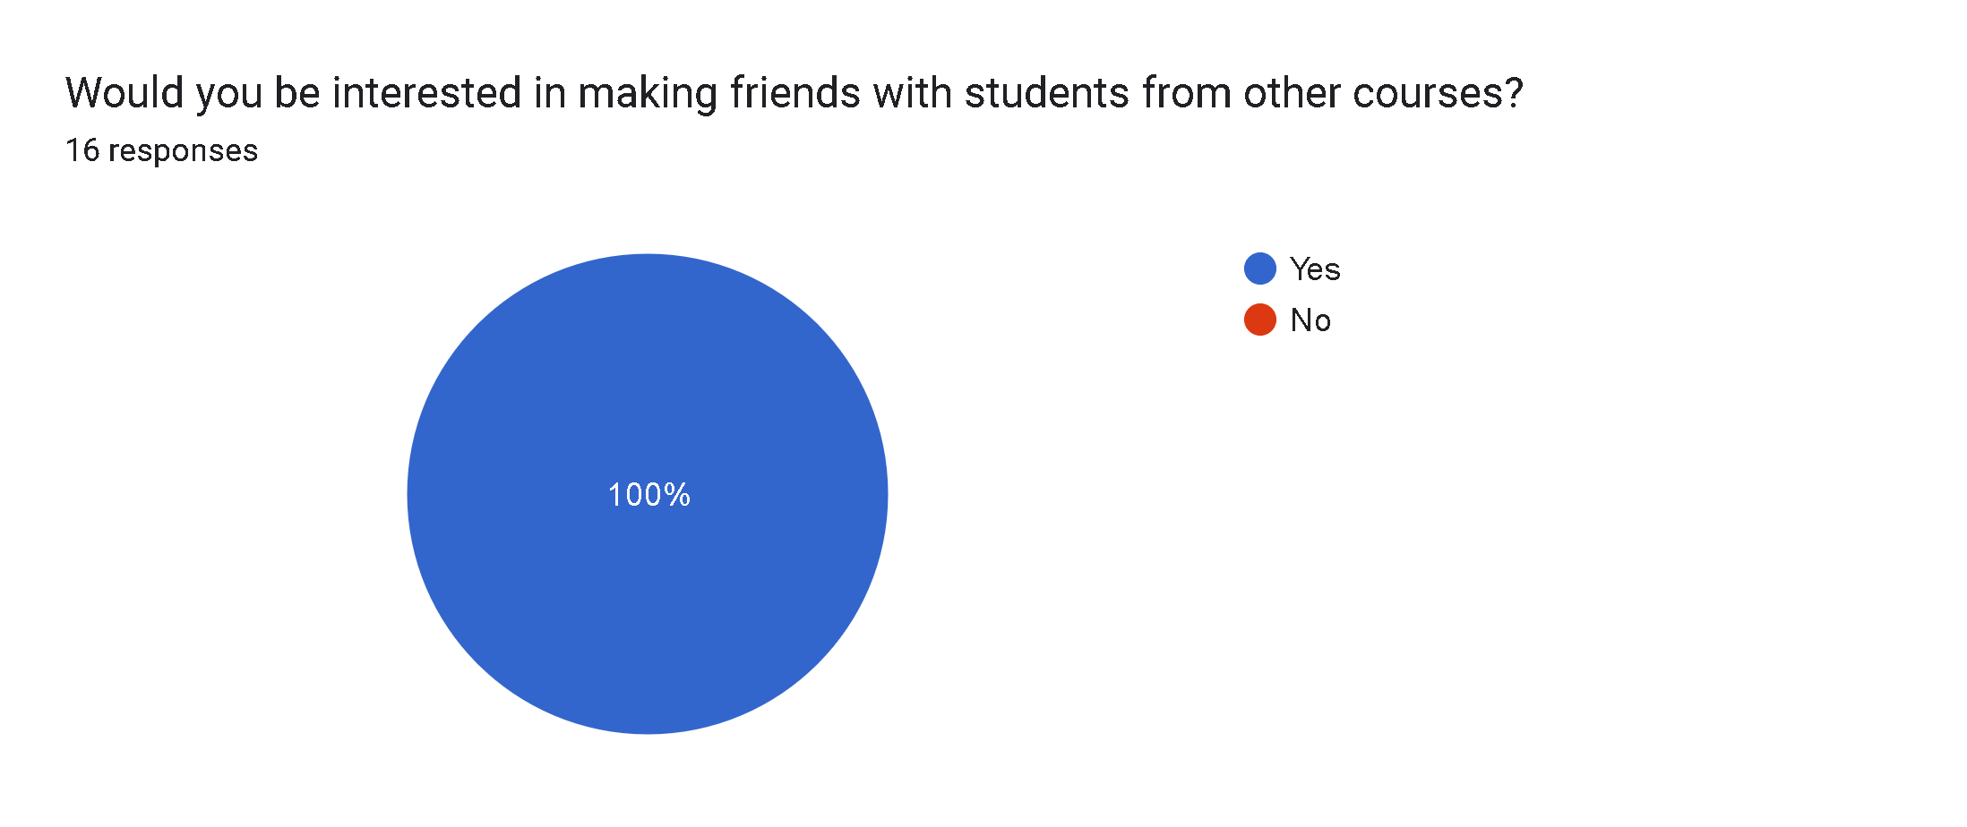

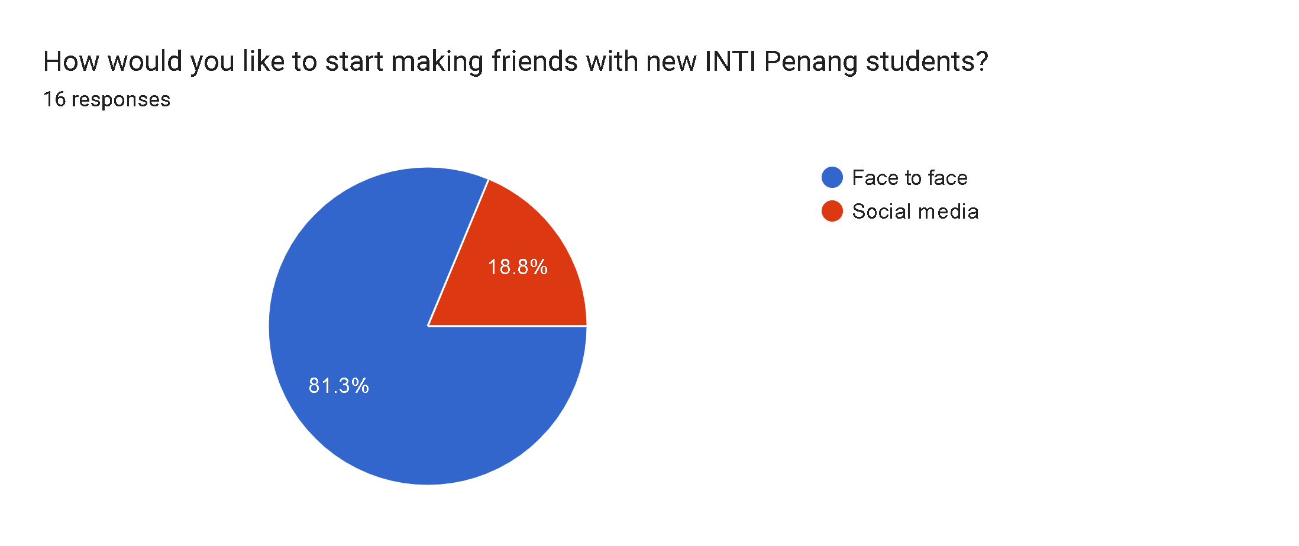

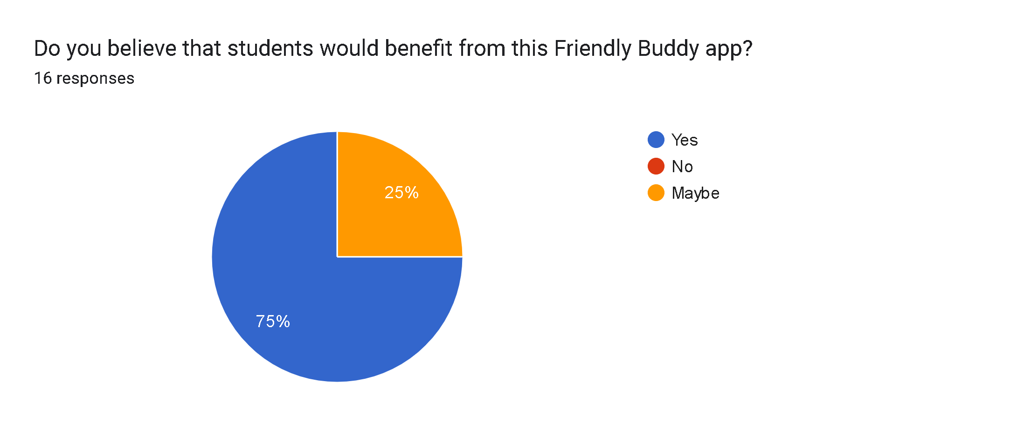

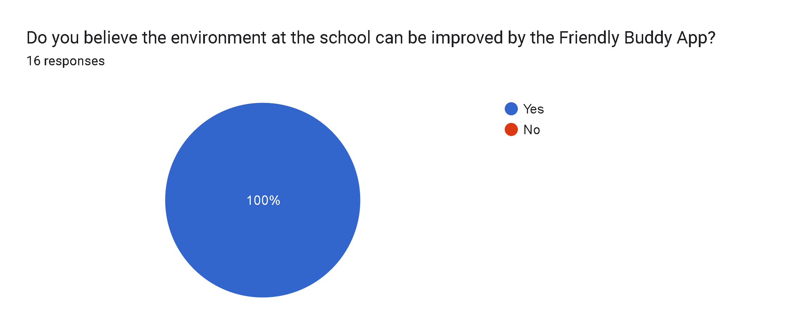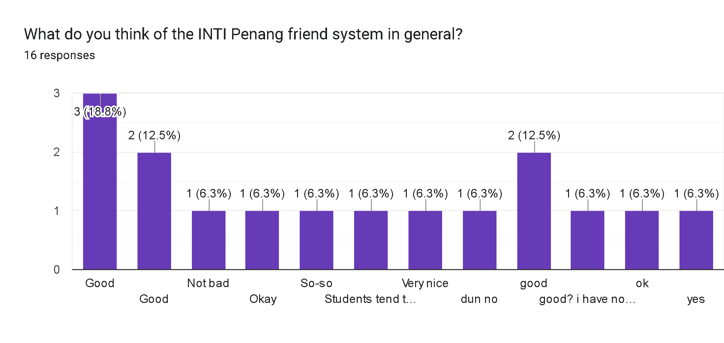

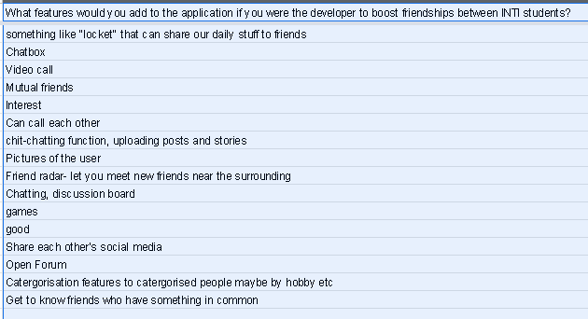

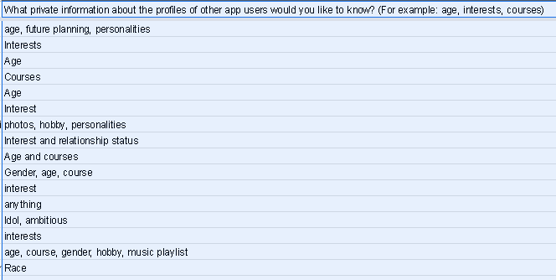

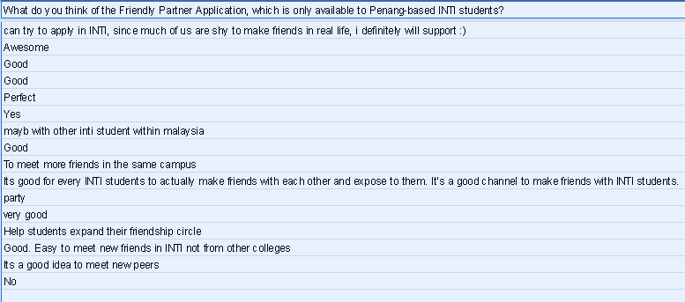

* 1. **User Story Mapping**

